Lazar Marjanovic

100405624

INFO 1113 A13

My site: https://sites.google.com/view/lazarminfo1113/file-cabinet

Project Experience

I think the project was good and necessary for our better understanding of how team works should cooperate towards a common goal. This project showed us how to be a part of a team that is well organized by its members. It was interesting to be a part of my group. I liked doing my task with my group members. I am always satisfied with my own results when I do something, but now I am more than satisfied when I see this group achieving the goal that we all worked on. Every member of the group worked hard with responsibility.

This project surely left a great experience that will help us understand group projects in the future.

This is my contribution to the group:

<https://trello.com/b/P2CGfpyZ/lazars-task>

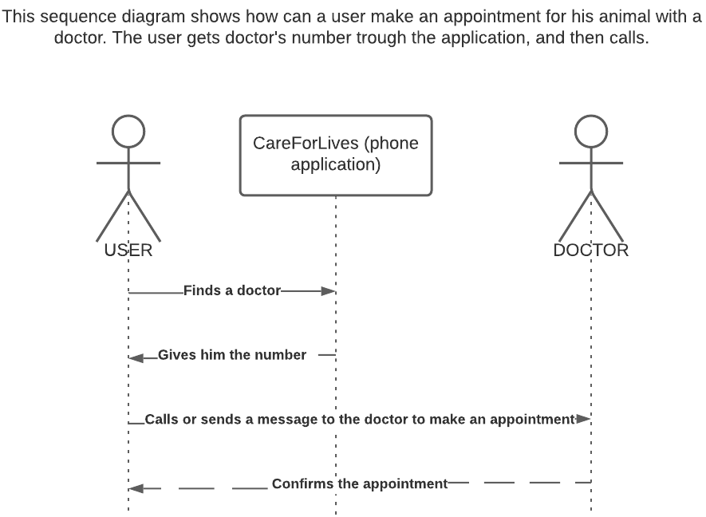

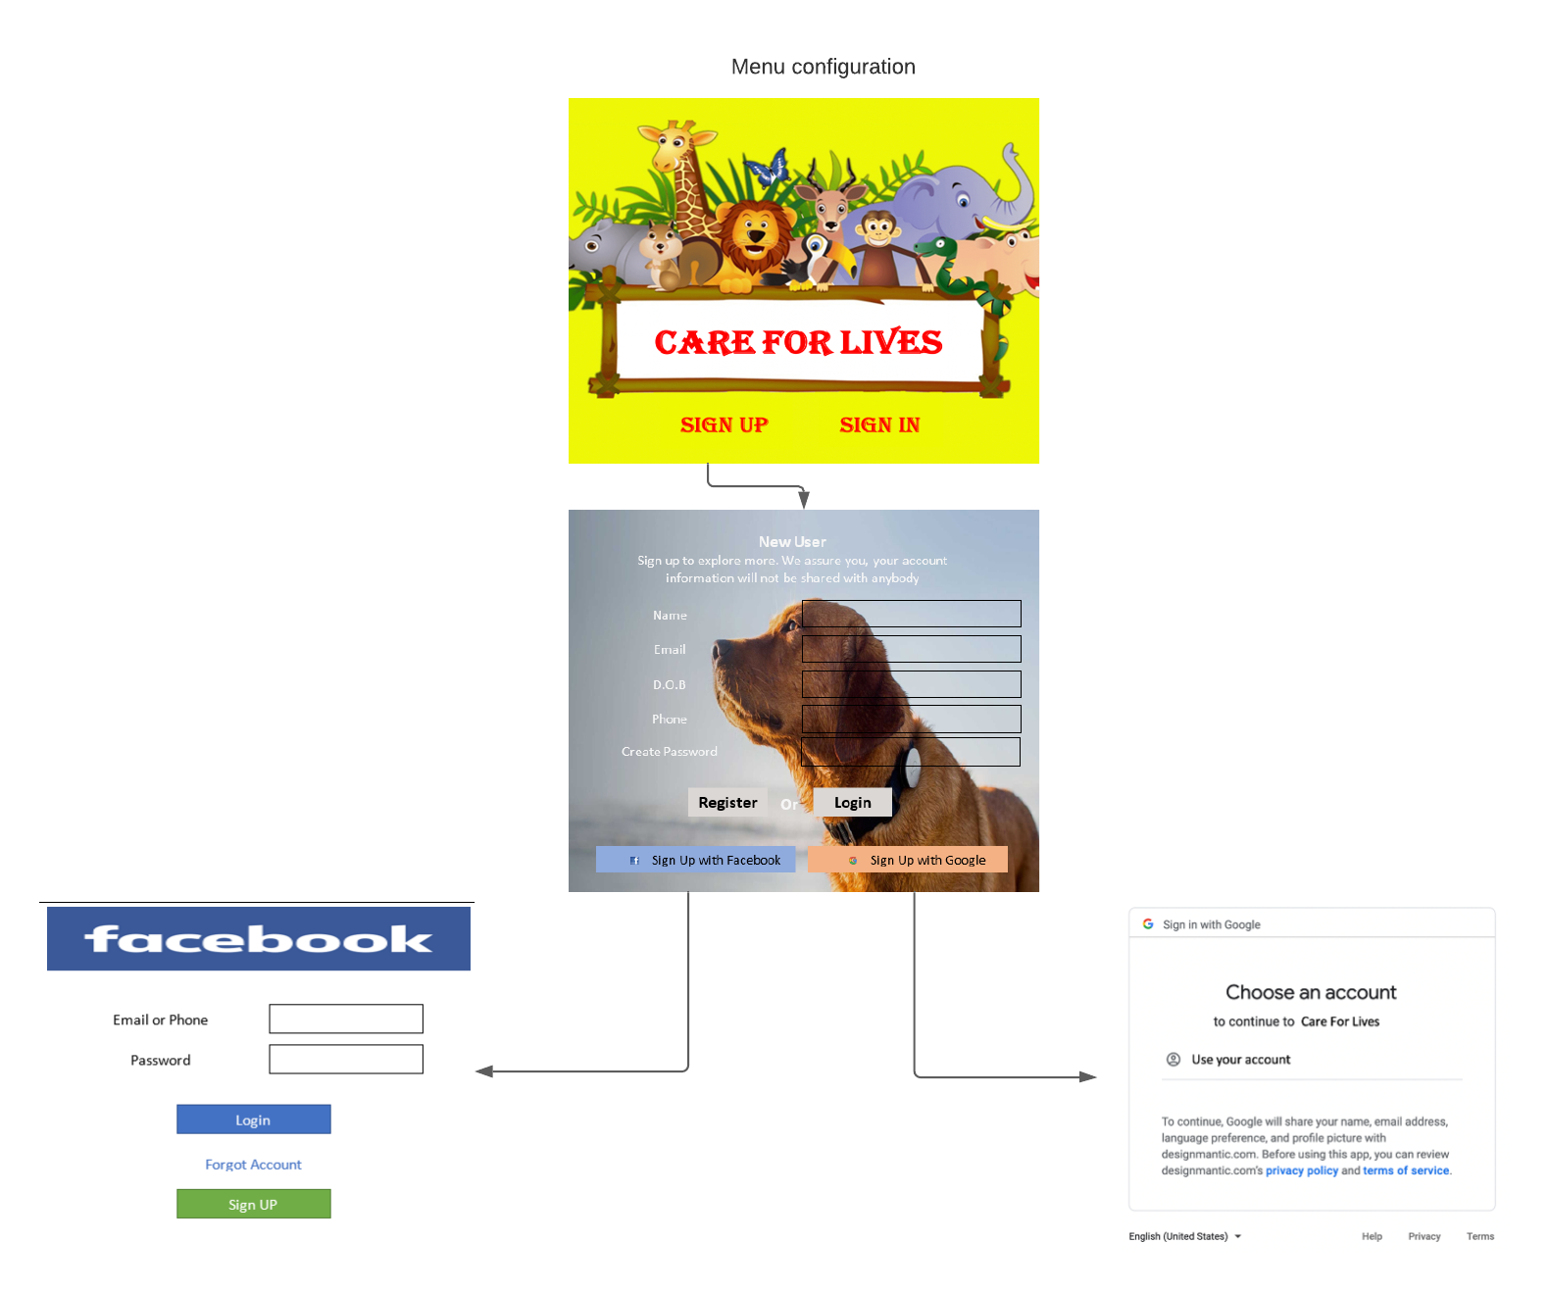

+reviews of work done by other students.